LAB 1 - Introduction, Standards and Basics of WLANs

Packet Tracer - Configure a Wireless Network

# Objectives

* Connect to a wireless router
* Configure the wireless router
* Connect a wired device to the wireless router
* Connect a wireless device to the wireless router
* Add an AP to the network to extend wireless coverage
* Update default router settings

# Introduction

In this activity, you will configure a wireless router and an access point to accept wireless clientsand route IP packets. Furthermore, you will also update some of the default settings.

# Instructions

## Connect to a Wireless Router

### Connect Admin to WR.

* + - 1. Connect **Admin** to **WR** using a straight-through Ethernet cable through the Ethernet ports. Select **Connections**, represented by a lightning bolt, from the bottom-left side of Packet Tracer. Click **Copper Straight-Through**, represented by a solid black line.
      2. When the cursor changes to connection mode, click **Admin** and choose **FastEthernet0**. Click **WR** and choose an available Ethernet port to connect the other end of the cable.

**WR** will act as a switch to the devices connected to the LAN and as a router to the internet. **Admin** is now connected to the LAN (**GigabitEthernet 1**). When Packet Tracer displays green triangles on both sides of the connection between **Admin** and **WR**, continue to the next step.

**Note**: If no green triangles are shown, make sure to enable **Show Link Lights** under **Options > Preferences**. You may also click **Fast Forward Time** just above the **Connections** selection box in the yellow bar.

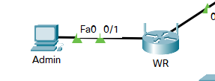

### Configure Admin to use DHCP.

To reach the **WR** management page, **Admin** must communicate on the network. A wireless router usually includes a DHCP server, and the DHCP server is usually enabled by default on the LAN. **Admin** will receive IP address information from the DHCP server on **WR**.

* + - 1. Click **Admin**, and select the **Desktop** tab.
      2. Click **IP Configuration** and select **DHCP**.

#### Questions:

What is the IP address of the computer?

192.168.0.100

What is the subnet mask of the computer?

**255.255.255.0**

What is the default gateway of the computer?

192.168.0.1

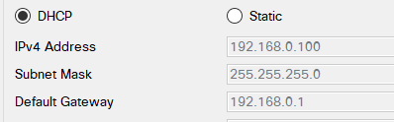

* + - 1. Close the **IP Configuration** window.

**Note**: Values can vary within the network range due to normal DHCP operation.

### Connect to the WR Web Interface.

* + - 1. In the **Desktop** tab on **Admin**, choose **Web Browser**.
      2. Enter **192.168.0.1** in the URL field to open the web configuration page of the wireless router.
      3. Use **admin** for both the username and password.

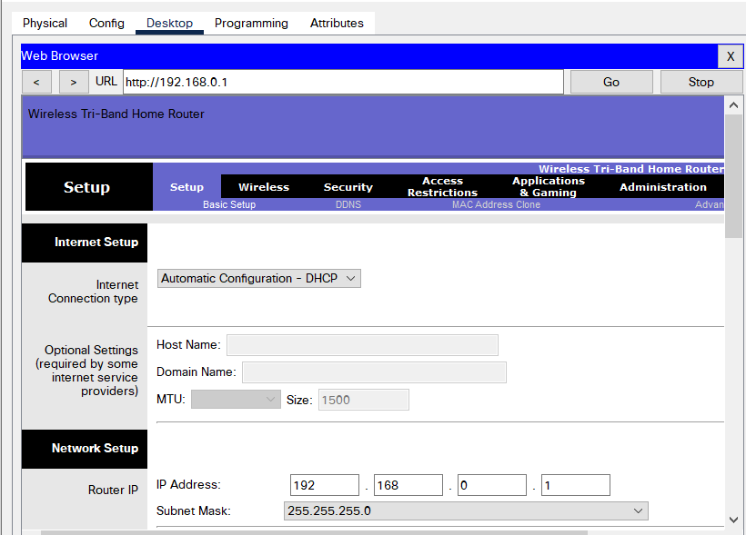

* + - 1. Under the Network Setup heading on the **Basic Setup** page, notice the IP address range for the DHCP server.



#### Question:

Is the IP address for **Admin** within this range? Is it expected? Explain your answer.

The IP for admin is 192.168.0.100 is the first IP of this range of IP. It is logical since Admin was attributed an address via DHCP (from WR).

### Configure the Internet Port of WR.

In this step, **WR** is configured to route the packets from the wireless clients to internet. You will configure the **Internet** port on **WR** to connect to the internet.

* + - 1. Under the **Internet Setup** at the top of the **Basic Setup** page, change the Internet IP address method from **Automatic Configuration – DHCP** to **Static IP**.
      2. Type the IP address to be assigned to the Internet interface as follows:

**Internet IP Address**: 209.165.200.225

**Subnet Mask**: 255.255.255.252

**Default Gateway**: 209.165.200.226

**DNS Server**: 209.165.201.1

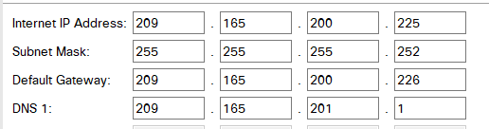

* + - 1. Scroll down the page and click **Save Settings**.

**Note**: If you get a **Request Timeout** message, close the Admin window and wait for the orange lights to turn into green triangles. Click the fast forward button to make this happen faster. Then reconnect to **WR** from **Admin’s** browser using the process explained in Step 3.

* + - 1. To verify connectivity, open a new web browser and navigate to **www.cisco.pka** server.

**Note** It may take a few seconds for the network to converge. Click **Fast Forward Time** or **Alt+D** to speed up the process.

## Configure the Wireless Settings

In this activity, you will only configure the wireless settings for 2.4 GHz.

### Configure the WR SSID.

* + - 1. Navigate to the **WR** GUI interface at **192.168.0.1** in a web browser on **Admin**.
      2. Navigate to **Wireless > Basic Wireless Settings**.
      3. Change **Network Name (SSID)** to **aCompany** for only 2.4 GHz. Notice that SSIDs are case-sensitive.
      4. Change the **Standard Channel** to **6 - 2.437GHz**.
      5. For this activity, disable both 5 GHz frequencies. Leave the rest of the settings unchanged.
      6. Scroll to the bottom of the window and click **Save Settings**.

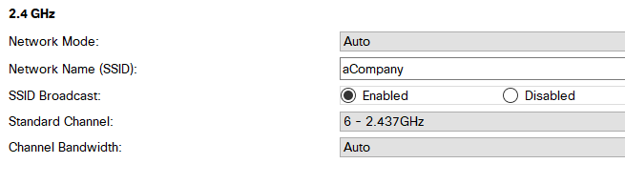

### Configure wireless security settings.

In this step, you configure the wireless security settings using WPA2 security mode with encryption and passphrase.

* + - 1. Navigate to **Wireless > Wireless Security**.
      2. Under the 2.4 GHz heading, select **WPA2 Personal** for the Security Mode.
      3. For the Encryption field, keep the default **AES** setting.
      4. In the Passphrase field, enter **Cisco123!** as the passphrase.

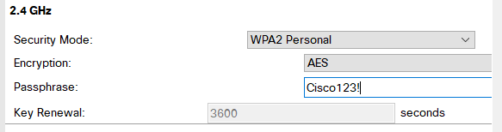

* + - 1. Click **Save Settings**.
      2. Verify that the settings in the **Basic Wireless Settings** and **Wireless Security** pages are correct and saved.

### Connect the Wireless Clients.

* + - 1. Open **Laptop1**. Select **Desktop** tab. Click **PC Wireless**.
      2. Select the **Connect** tab. Click **Refresh** as necessary. Select the Wireless Network Name **aCompany**.
      3. Enter the passphrase configured in the previous step. Enter **Cisco123!** In the pre-shared key field and click **Connect**. Close the PC Wireless window.

* + - 1. Open a web browser and verify that you can navigate to **www.cisco.pka** server.
      2. Repeat the above steps to connect **Laptop2** to the wireless network.

## Connect Wireless Clients to an Access Point

An access point (AP) is a device that extends the wireless local area network. An access point is connected to a wired router using an Ethernet cable to project the signal to a desired location.

### Configure the Access Point.

* + - 1. Connect **Port 0** of **AP** to an available Ethernet port of **WR** using a straight-through Ethernet cable.
      2. Click **AP**. Select the **Config** tab.
      3. Under the INTERFACE heading, select **Port 1**.
      4. In the SSID field, enter **aCompany**.
      5. Select **WPA2-PSK**. Enter the passphrase **Cisco123!** In the Pass Phrase field.
      6. Keep **AES** as the default Encryption Type.

### Connect the Wireless Clients.

* + - 1. Open **Laptop3**. Select **Desktop** tab. Click **PC Wireless**.
      2. Select the **Connect** tab. Click **Refresh** as necessary. Select the Wireless Network Name **aCompany** with the stronger signal (Channel 1) and click **Connect**.
      3. Open a web browser and verify that you can navigate to **www.cisco.pka** server.

## Other Administrative Tasks

### Change the WR Access Password.

* + - 1. On **Admin**, navigate to WR GUI interface at **192.168.0.1**.
      2. Navigate to **Administration > Management** and change the current **Router Password** to **cisco**.
      3. Scroll to the bottom of the window and click **Save Settings**.
      4. Use the username **admin** and the new password **cisco** when prompted to log in to the wireless router. Click **OK** to continue.
      5. Click **Continue** and move on to the next step.

### Change the DHCP address range in WR.

In this step, you will change the internal network address from 192.168.0.0/24 to 192.168.50.0/24. When the LAN network address changes, the IP addresses on the devices in the LAN and WLAN must be renewed to receive new IP addresses before the lease is timed out.

* + - 1. Navigate to **Setup > Basic Setup**.
      2. Scroll down the page to **Network Setup**.
      3. The IP address assigned to **Router IP** is 192.168.0.1. Change it to 192.168.50.1. Verify that IP address still start at .100, and there are 50 available IP addresses in the DHCP pool.
      4. Add **209.165.201.1** as the DNS server with the DHCP settings.
      5. Scroll to the bottom of the window and click **Save Settings**.

* + - 1. Note that the DHCP range of addresses has been automatically updated to reflect the interface IP address change. The Web Browser will display a **Request Timeout** after a short time.

#### Question:

Why?

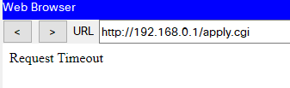

The admin IP address and the router are not in the same network, and the admin address is outside the new range of addresses.

* + - 1. Close the **Admin** webbrowser.
      2. In **Admin Desktop** tab, click **Command Prompt**.
      3. Type **ipconfig /renew** to force **Admin** re-acquire its IP information via DHCP.

#### Question:

What is the new IP address information for **Admin**?

The new IP address is 192.168.50.100

Type your 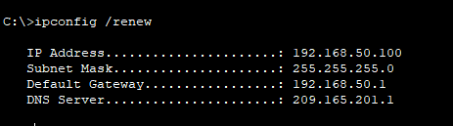answers here.

* + - 1. Verify that you can still navigate to **www.cisco.pka** server.
      2. Renew the IP address on other laptops to verify that you can still navigate to **www.cisco.pka** server.
      3. Notice that **Laptop1** connected to the **AP** instead of **WR**.

#### Question:

Why?

The signal was better with AP than with WR.

Type your answers here.

End of Document